**Physics 30 – Lesson 15**

**Electric Fields**

/57

**Practice problems**

1)



2)



The direction of the electric field will be toward the charge.



The assumption made is that the charge is concentrated at the centre of the sphere and acts like a point charge.



3)



4)



5)



**Assignment**

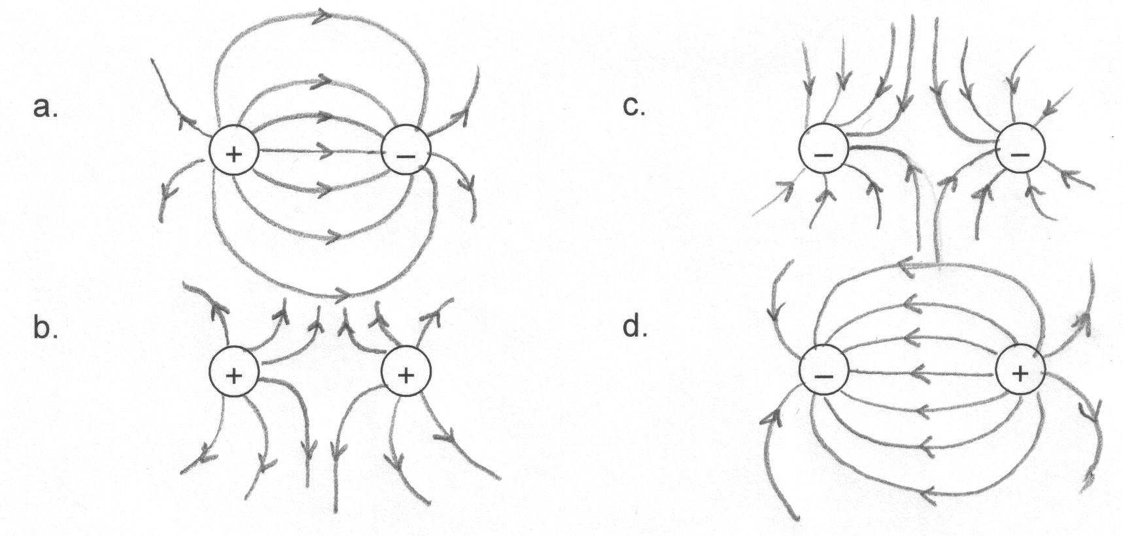1)

/4

–

–

–

–

–

–

–

–

–

–

–

–

–

–

–

–

–

–

–

–

–

**– – –**

**–**

**–**

**–**

**–**

**–**

**–**

**–**

**–**

**–**

**– – – –**

**–**

**–**

**– ­–**

**– –**

**–**

**– –**

**– –**

2)

/4

3) A small test charge would not interfere with the electric field being mapped.

/1

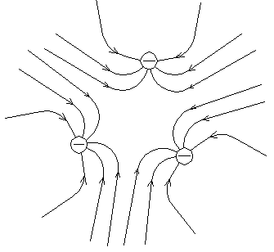

4)

in the center 

/4

5)

The assumption made is that the charge is concentrated at the centre of the sphere and acts like a point charge.



/8

6)



/6



7)



/ 2

8)





9)





10)



35 cm

35 cm



/10



11)



- -

- -

- -

- -

- -

- -

- -

because the electric field inside a conductor is zero



12)

•



/5

13) Since the electric field points into the Earth, the Earth has a negative electric field



/5